Chapter 4, Solution 16.

Given the circuit in Fig. 4.84, use superposition to obtain i_{o}.

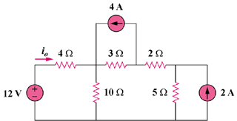

Figure 4.84
For Prob. 4.16

Solution

Let i_{o} = i_{o1} + i_{o2} + i_{o3}, where i_{o1}, i_{o2}, and i_{o3} are due to
the 12-V, 4-A, and 2-A sources. For i_{o1}, consider the circuit below.

12V

+
−

4 Ω

10 Ω

i_{o1}

5Ω

2 Ω

3 Ω

10||(3 + 2 + 5) = 5 ohms, i_{o1} = 12/(5 + 4) = (12/9) A

i_{o2}

3 Ω

5 Ω

4Ω

2 Ω

10Ω

4A

i₁
For i_{o2}, consider the circuit below.

2 + 5 + 4||10 = 7 + 40/14 = 69/7
i₁ = [3/(3 + 69/7)]4 = 84/90, i_{o2} =[-10/(4 + 10)]i₁ = -6/9

For i_{o3}, consider the circuit below.

3 Ω

4 Ω

5 Ω

10 Ω

i_{o3}

2 A

i₂

2 Ω

3 + 2 + 4||10 = 5 + 20/7 = 55/7

i₂ = [5/(5 + 55/7)]2 = 7/9, i_{o3} = [-10/(10 + 4)]i₂ = -5/9

i_{o} = (12/9) – (6/9) – (5/9) = 1/9 = 111.11 mA

